**Technical Challenge**

**ToyRobot TableTop Simulation:**

I have written the code in C# .net 8 version and follow the command pattern with clean architecture. In this solution has 3 projects, ToyRobot (core functionality), Simulator(client) and Unit Test.

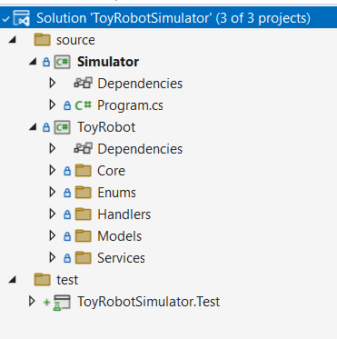

**Simulator Test-1:**

PLACE 0,0,NORTH

MOVE

REPORT

Output: 0,1,NORTH

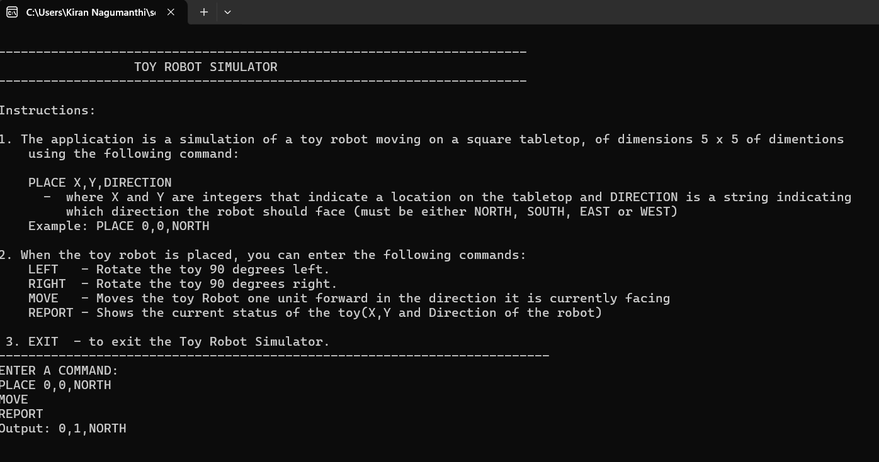

**Simulator Test-2:**

PLACE 0,0,NORTH

LEFT

REPORT

Output: 0,0,WEST

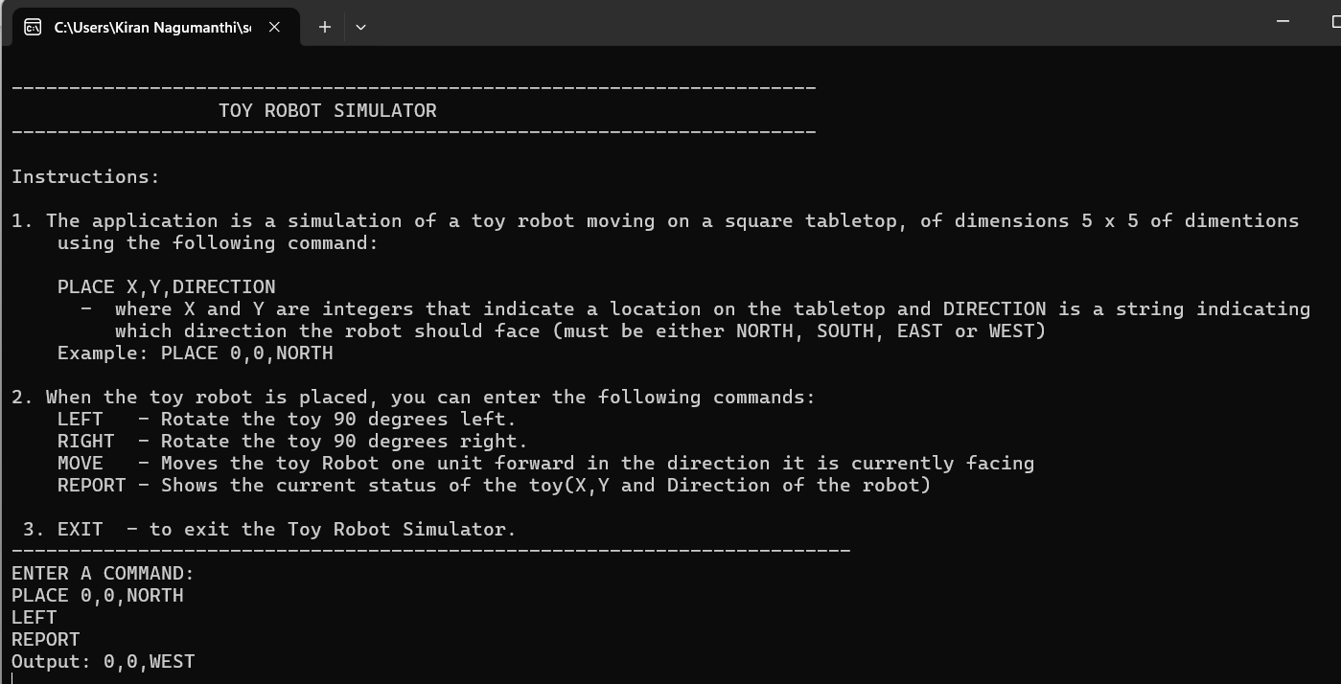

**Simulator Test-4:** Move commands beyond the line will be discarded

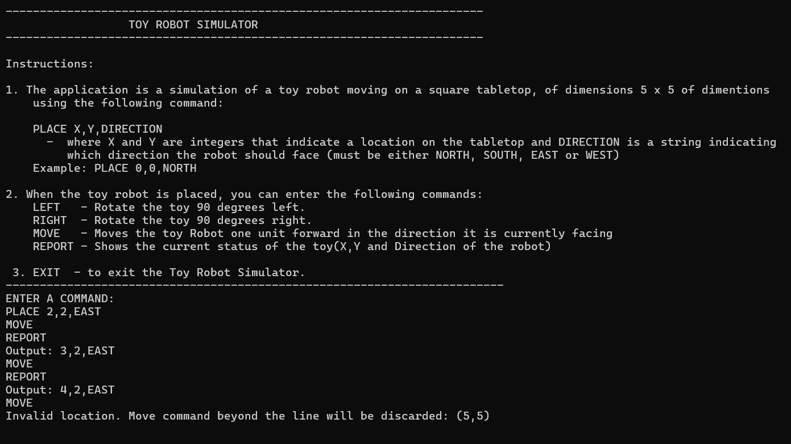

**Simulator Test-5:** Invalid commands

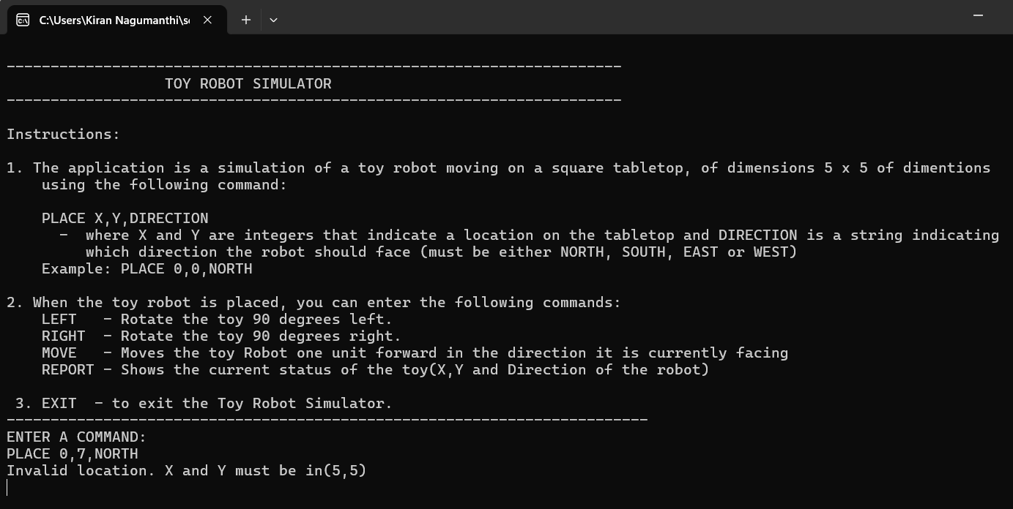

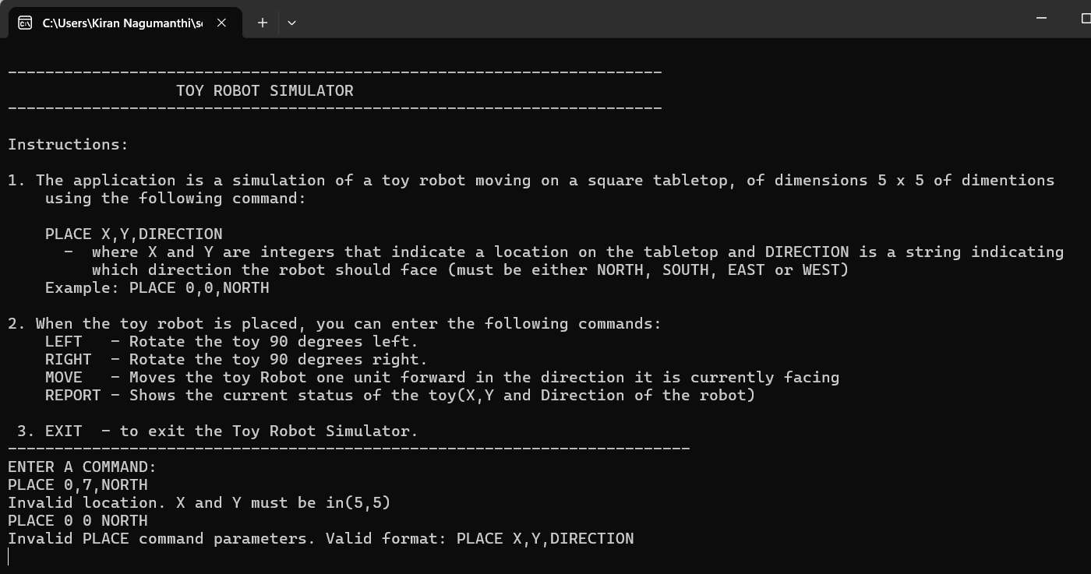

**Unit Test Cases:**

